Storytelling tour October 2012

“With Restauration through Hell Gate to The Promised Land”.

Storyteller Anne Elisebeth Skogen

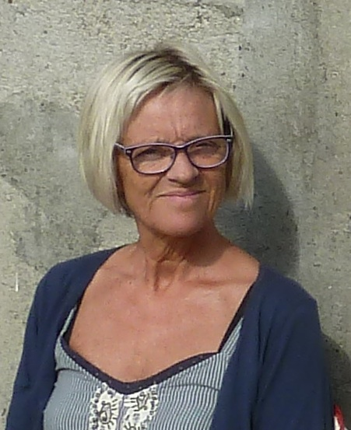

Week 40
06.10.12 Saturday: Washington DC, 4:00, together with musicians
Patrik Wingård, Richard Burgess and KorLuren from Fredrikstad No
Address: Stacy C. Sherwood Community Center, 3740 Old Lee Hwy, Fairfax,
VA 22030.

07.10.12 Sunday: Chicago, 12:30pm
Address: Norwegian Lutheran Memorial Church (Minnekirken)
2614 N. Kedzie Blvd, Chicago, IL 60647

Week 41
10.10.12 Wednesday: Decorah, Iowa, at 7:00 pm
Address: Betania, a church at Vesterheim,
Norwegian-American Museum, Decorah IW

13.10.12 Saturday: Omaha, Nebraska, at 11:00am
Address: W. Dale Clark Main Library 215 S. 15th, St. Omaha, Ne 68102

Week 42
16.10.12 Tuesday: Minneapolis, Minnesota, Dinner at 7:00 pm, show at 8:30
Address: Minnetonka
Community Center,
14600 Minnetonka Blvd

19.10.12 Friday: Staten Island, NY, dinner at 7.00 pm, show at 8:30
Address: Nansen Lodge. 3451 Victory Blvd. Staten Island 10314 N.Y.

20.10.12 Saturday: Lake Telemark, New Jersey, 6:30 pm
Address: BUL Cabin, Oslo Drive, Lake Telemark, NJ 07866

21.10.12 Sunday: Marlboro, New Jersey, 3:00 pm
Address: Noreg Lodge 3-466, 80 Boundary Road, Marlboro, New Jersey 07746

